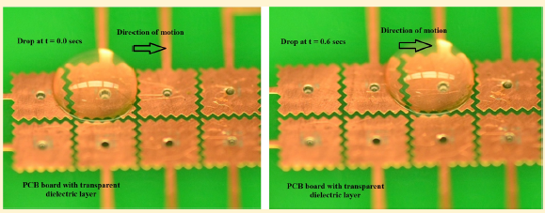

This is the setup used for attached snapshots. Electrode pads are 3 mm x 3 mm with a 0.15 mm gap. For all videos I dripped 4 droplets from a 34 ga needle. These 4 droplets weighed 0.0096 g on our balance.